A000-CAN-BC-Kwakiutl-Mask-by Godfrey Hunt Sr-*1981*

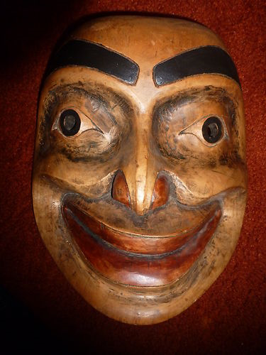 SHAPE \* MERGEFORMAT 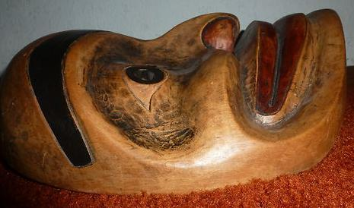

Figs. 1-2. Kwakiutl-Mask-by Godfrey Hunt Sr-*1981*

Case No.: 8

**Accession No.**

**Formal Label:** Kwakiutl-Mask-by Godfrey Hunt Sr-*1981*

**Display Description:**

The mask is in excellent condition with deeply carved eyes etc. It has hand carved inscription on the back as follows: Godfrey April-1981  CRA-1895 "For Bruce Cramer"  Thanks for letting the Goof build in yard.

**LC Classification:**

**Date or Time Horizon:**

**Geographical Area:**

**Map:**

**GPS coordinates:**

**Cultural Affiliation:**

**Media:**

**Dimensions:** 12-1/2" Long x 10-1/2 Wide x 4-6" Deep

**Weight:** : 3 Lbs

**Condition:**

**Provenance:**

**Discussion:**

**References:**

Appendix:

